**Class:** Final Year (Computer Science and Engineering)

**Year:** 2022-23 **Semester:** 1

**Course:** High Performance Computing Lab

**Practical No. 1**

**Exam Seat No:**

1. 2019BTECS00038 – Sadaf Najeem Mulla

**Title of practical:** Hello World program and Sum of squares of numbers

**Problem Statement 1:** Hello Word

**Screenshots:**

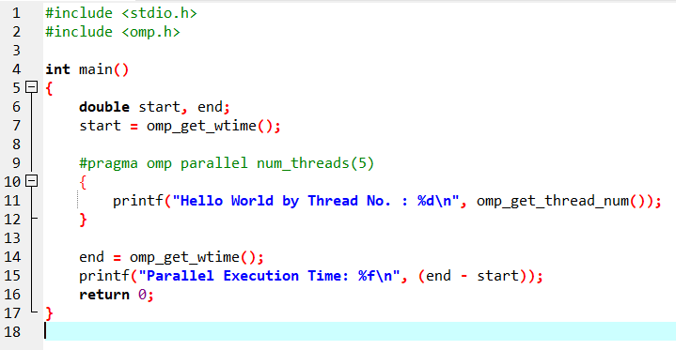

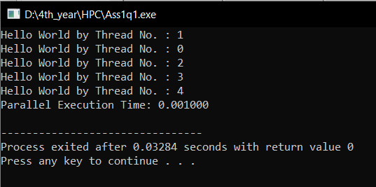

**Information :**

We have to include the OpenMP header for our program along with the standard header files.

Mention the region which we are going to make it as parallel using the keyword pragma omp parallel. It is used to fork additional threads to carry out the work enclosed in the parallel. The original thread will be denoted as the master thread with thread ID 0.

We can set the number of threads to execute the program using the external variable.

**Problem Statement 2:** Sum of squares of numbers from 1 to 100

**Screenshots:**

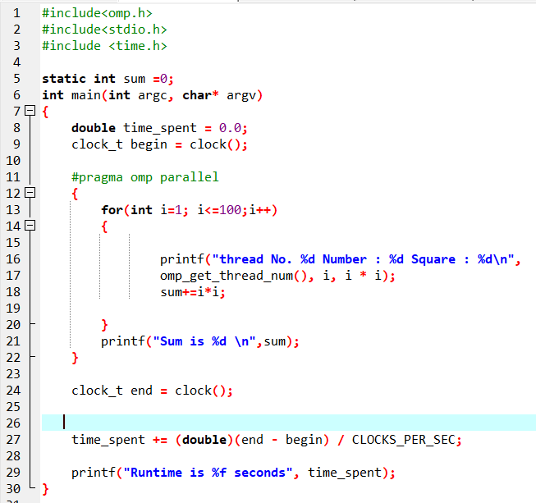

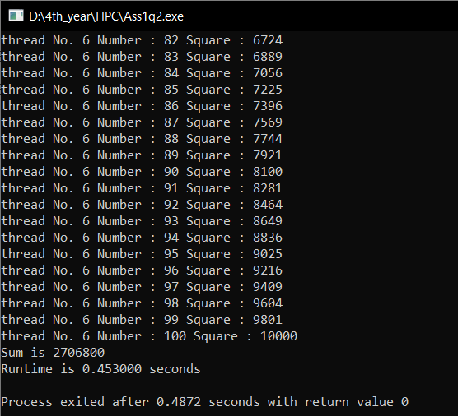

**Information :**

We take square of each number and add it to variable sum.

omp parallel directive explicitly instructs the compiler to parallelize the chosen block of code.

And we print the thread no that is running.

**Github Link:** [**https://github.com/sadafmulla/HPC_LAB/tree/main/Assignment1**](https://github.com/sadafmulla/HPC_LAB/tree/main/Assignment1)